The New World of ADU’s

ADU’s are Accessory Dwelling Units. In an effort to help our housing shortage, the States of Massachusetts and New Hampshire have passed new zoning laws that make it easy for you to add an apartment to your single family property.
So now homeowners can add an ADU to their property, bypassing most local zoning regulations. It can be rented out to anyone, not just relatives.
This is a huge step forward. The social benefits are obvious. Seniors could downsize into a new dwelling on their existing property and rent out the main house to anyone they want, or help out a family member who is priced out of the current housing market. Anyone can create additional value to their home by adding a rentable unit. If you have the space in your home to create an additional residence, it doesn’t have to involve the actual cost of building new and you can generate rental income from your property.
And from an environmental point of view, it’s a win - win: no need to build more roads, which causes significant damage and usually requires a lot of tree cutting and land clearing, as well as costing the town to maintain and plow going forward.
How does it work? If you occupy a single family home, you have the right to add a unit. It can be a separate building, attached to your house, or in your house. It must have a separate entrance and most towns require off street parking. Zoning setbacks from side, front and back of property must be respected. The addition should be appropriately designed and situated so as not to be an eyesore. Finally, size may not exceed half the living area of your house or 900 square feet, whichever is smaller.
It can also be above your garage or in your basement, as long as it meets building code and has own entrance. Each town will have some of its own specific requirements such a location on the lot, parking requirements and lot coverage. You will want a professional schooled in ADU’s to guide you and handle the permitting.
So now you can add a second dwelling to your property or even your children’s property! It solves so many needs, including helping seniors to downsize and freeing up larger homes for new occupants.
Towns will be looking for a professional design showing access and location of proposed residence, so talk to a local professional about your needs. Also visit Newburyport’s Green Expo on May 19th at the Bresnahan School and Senior Center for more information and many other great ways to help our environment!
- Copilot Answer

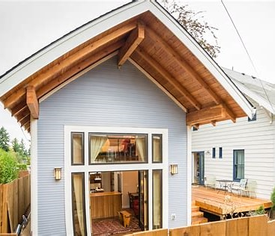

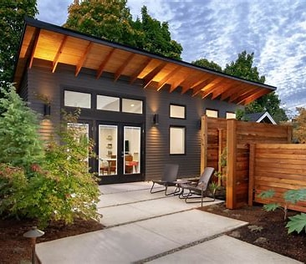

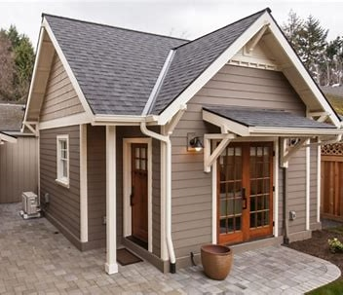

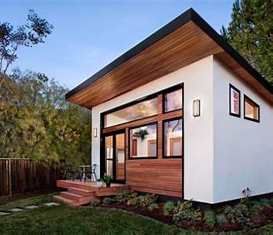

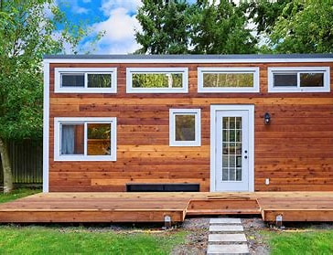

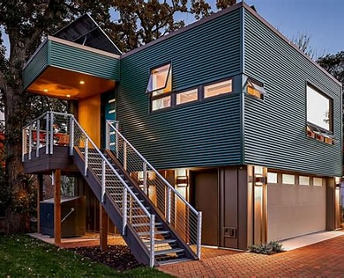

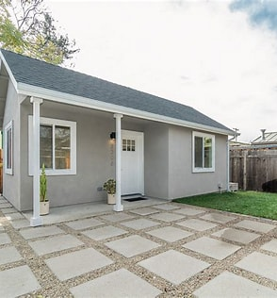

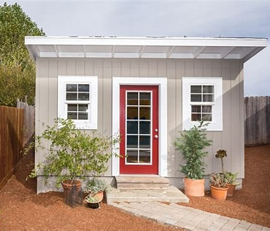

Explore images of adu


Cast


Freddy Adu Soccer


Awards


Freddy Adu Teams


Netflix Originals


Soccer Players


Building an ADU
https://www.buildinganadu.com › adu-photos-home

Photos of ADUs (Accessory Dwelling Units) - Building an ADU
  - 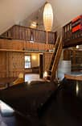
  - 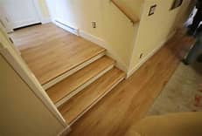
  - 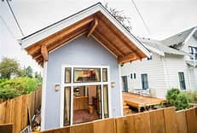
  - 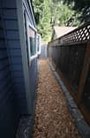
  - 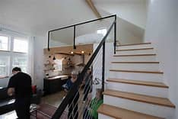
Browse hundreds of photos of ADUs (Accessory Dwelling Units) in various categories and styles. Find built examples of ADUs with artistic features, basement conversions, lofts, outdoor space …
Other content from buildinganadu.com
  - ADU Photo Assortment - Building an ADU
  - Photos of ADU Construction - Building an ADU
See more


Dwell
https://www.dwell.com › article

22 ADU Floor Plans That Make the Most of the Backyard - Dwell

    - Northwood ADU by T+E+A+M.
    - Stop Making Sense ADU by Bunch Design.
    - Cronus House by AllThatIsSolid.
    - Santa Monica ADU by Lewis | Schloeplein Architects.
See full list on dwell.com


Houzz
https://www.houzz.com › photos › query › adu-ideas

Adu Ideas - Photos & Ideas | Houzz
  - 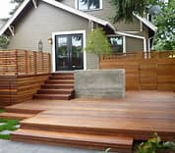
  - 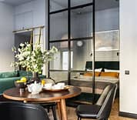
  - 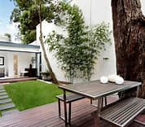
  - 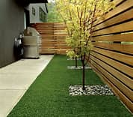
  - 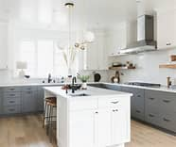
Browse photos of adu ideas on Houzz and find the best adu ideas pictures & ideas.

Building an ADU
https://www.buildinganadu.com › adu-photo-assortment

ADU Photo Assortment - Building an ADU
  - 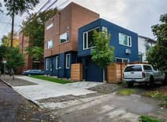
  - 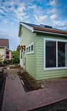
  - 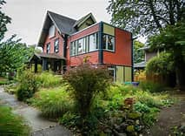
  - 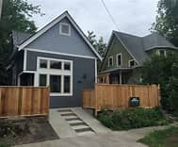
  - 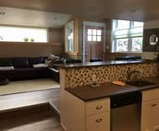
This is a large assortment of miscellaneous photos of ADUs. We also have categorized list of ADUs by topic (eg. basement conversion, closets and storage, tall ceilings, space efficiency …
- 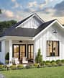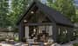


Architectural Designs
https://www.architecturaldesigns.com › ... …

ADU House Plans - Architectural Designs
Discover ADU house plans perfect for added living space or rental units. Our customizable ADU plans, floor plans & house designs are available in many architectural styles.


SnapADU
https://snapadu.com › gallery › adu-exterior-photos

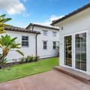

ADU Exterior Design Ideas Photo Gallery | Snap ADU
In this comprehensive guide to accessory dwelling unit exterior styles and options in Greater San Diego, we delve into the various facets of ADU exterior design and finishes, ensuring the creation of an attractive ADU that adheres to all building …


gladconstruction.com
https://gladconstruction.com › new-build...

ADU Images & Ideas: Modern ADU Designs | Inspiration Gallery
Aug 10, 2024 · Explore a diverse range of ADU images showcasing various design styles and settings. From cozy cabins to sleek modern structures, these visuals offer inspiration for your …

SnapADU
https://snapadu.com › gallery

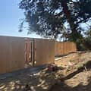

ADU Photos - Photo Galleries - Snap ADU Design Build
Check out photos of our ADU designs, including interior and exterior renderings and photos of real accessory dwelling unit projects.

  - 
America's Best House Plans
https://www.houseplans.net

Shop Now

ADU House Plans - Build Your Own Dwelling Unit
SponsoredBrowse 20,000+ Hand-Picked House Plans From The Nation's Leading Designers & Architects! View Interior Photos & Take A Virtual Home Tour. Let's Find Your Dream Home Today!
Affordable Customizations · Over 17,000 Home Plans · Huge Selection of Styles
15% off Flash Sale! · Valid May 12 - May 13
Types: Modern Farmhouse · Barndominium · Farmhouse · Craftsman · Country
Amenities: Under 1000 Sq Ft · 1001 To 1500 Sq Ft · 1500 To 2000 Sq Ft
  - 
Etsy
https://www.etsy.com

Shop Now

ADU Floor Plans - Small House Plans for Adu
SponsoredShop Bath & Beauty Items And More Fresh Finds Waiting To Be Explored. Handmade, Handpicked, and Designed By Humans
Site visitors: Over 1M in the past month
Secure Shopping · Free Shipping Available
- Related searches for adu images

adu model home pictures

pics of adu's

pictures of adu homes

images of adu units

accessible dwelling unit images

accessory dwelling unit photos

additional dwelling units images

pictures of accessory dwelling units

  - 1
  - 2
  - 3
  - 4

- Explore with images


Adu Movie 2020


Adu Netflix


Adu Cast


Freddy Adu Soccer


Adu Awards

See more

- Related searches

adu model home pictures

pics of adu's

pictures of adu homes

images of adu units

accessible dwelling unit images

accessory dwelling unit photos

additional dwelling units images

pictures of accessory dwelling units

